**Software Testing Assingment**

**Module-1(Fundamental)**

1. **What is SDLC?**

* SDLC is stand for software development lifecycle.
* SDLC is a structure imposed on the development of the Software product.That defines the process of planning planning,implementation,testing,deployment,ongoing maintenance and support.

1. **What is Software Testing?**

* Software testing is a process of used to identify correctness,completeness and quality developed computer software.

**(3) What is Agile Methodology?**

* A software requirement specification is a completed description of the behaviour of the system to be developed.

1. **What is SRS?**

* A software requirement specification is a complete description of the behaviour of the system to be developed.

1. **What is oops?**

* Object Oriented Programming Language is a programming paradigm that uses objects and classes in programming.

1. **Write basic concept of oops?**

* Object
* Class
* Inheritance
* Polymorphism
* Encapsulation
* Abstraction

1. **What is Object?**

* Object is a variable of a class.

1. **What is class?**

* Class is a collection of data member and member function with it’s behavior.

1. **What is Encapsulation?**

* Encapsulation is data hiding and wrapping up of data into single unit.

1. **What is Inheritance?**

* Inheritance is properties of parent class extends into child class.

1. **What is Polymorphism?**

* Polymorphism is ability to take one name having many form or multiple forms.

1. **Draw usecase on online book shopping?**

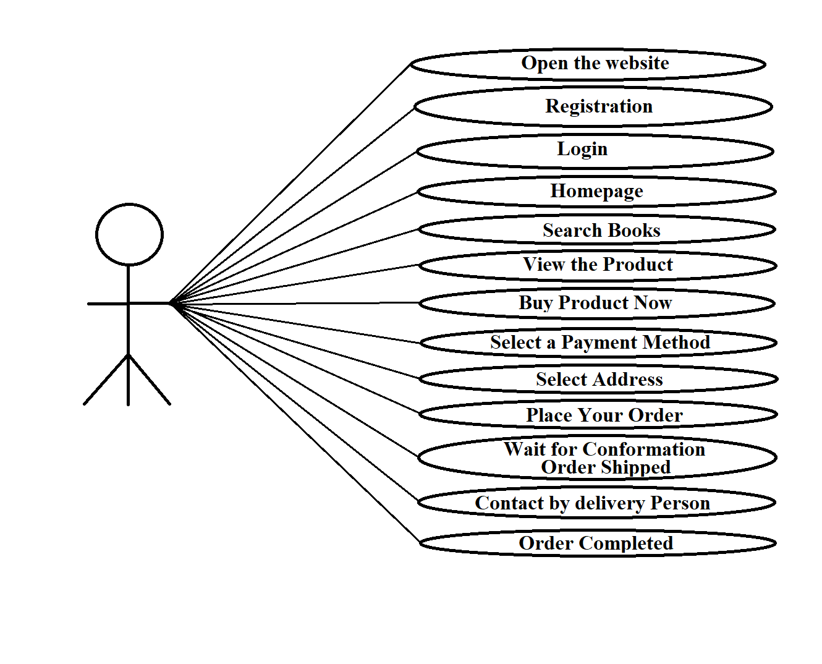

**(13) Draw usecase on online bill payment system(paytm).**

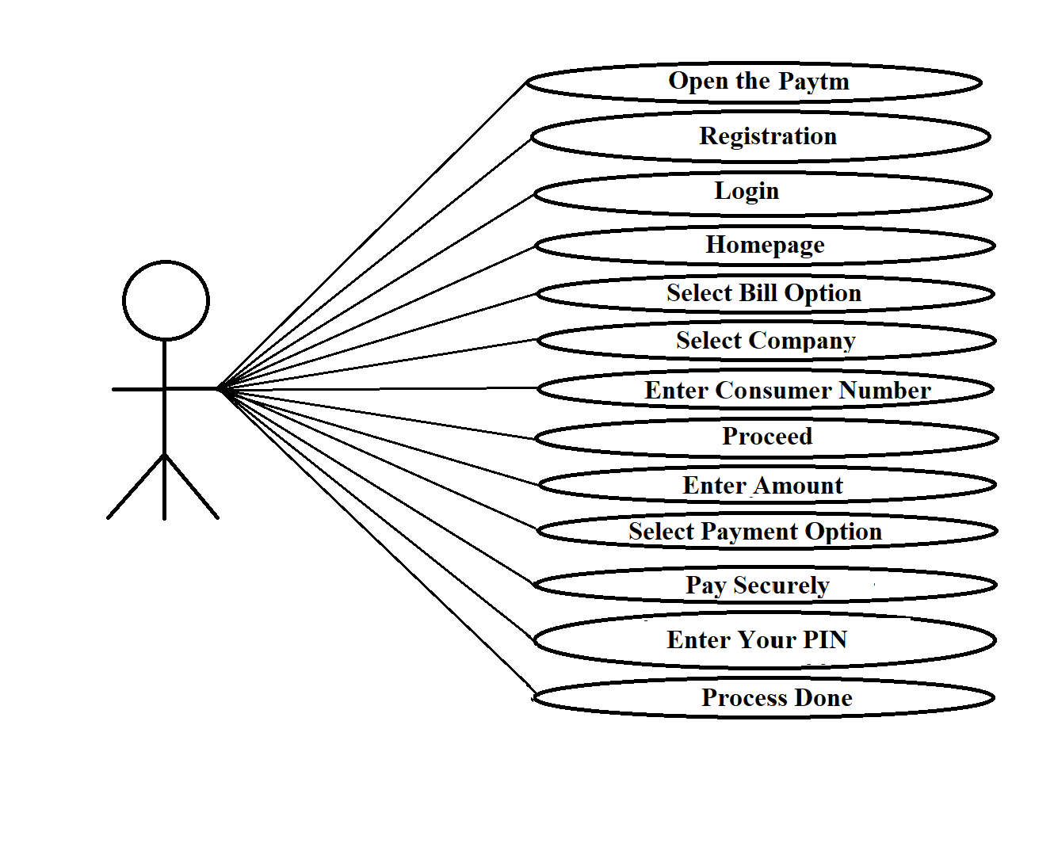

1. **Write SDLC Phases with basic introduction.**

* **SDLC Phashes :**

1. **Requirement Gathering :**

* User needs change during the project.
* There are two type Functional and non-functional requirement.
* Requirement will change.
* There are three types of problems:
* Lack of clarity
* Requirement confusion
* Requirement amalgamation

1. **Analysis Phase:**

* The analysis phase represents the “what” and “how”

Phase.

* This phase start with the requirement document delivered by requirement phase.
* The deliverable result at the end of the phase is requirement document.

1. **Design Phase :**

* Design phase is used to Architecture document.
* Developers create design to achieve the project goals.
* The architecture team convert the scenarios into testplan.

1. **Implementation Phase:**

* In the implementation phase the team builds the component either document from the design phase.
* Implementation code.
* The implementation phase deal with issue of qhality and performance.

1. **Testing phase:**

* The developer find out defect and bugs whether their code and programming.
* Simple stated,quality is very important.

1. **Maintenance Phase:**
2. Maintenance phase is the process of changing a system.

- Corrective maintenance

- Adaptive maintenance

- Perfective maintenance

1. **Explain Phases of the Waterfall Model.**

* Waterfall model is classical software lifecycle n the software development as a step by step “Waterfall” between the various development phases.
* Waterfall is unrealistic for many reasons:
* Requirement must be Frozen to early in life product.
* The project is short.
* There are many waterfall phases:
* Requirement gathering
* Analysis
* Design
* Implementation
* Testing
* Maintenance
* Why waterfall model:

- Simple and easy to understand and use.

- Easy to manage due to the rigidity of the model.

- Easy to arrange tasks.

- Well understood and milestone.

* Why not waterfall model:
* Not a good model for complex and object oriented project.
* Poor model for long and ongoing project.
* High amount of risk.

1. **Write phases of Spiral model.**

* **The Spiral model are four phases:**

**Planning:**

* That define initial requirement.
* Determination of objective, alternative and constraints for current iteration.

1. **Risk Analysis:**

* Analysis and identification of risk.
* That will delay project or increase its cost.

1. **Engineering :**

* it start next level development of the product.
* Develop and implement the product accoding to the requirement.

1. **Customer evaluation :**

* Test the system and evaluate the project goal and risk.
* The performance of the developed software gets tested

1. **Write Agile manifesto principle.**

* **There are four agile manifesto principles:**

1. **Working software:**

The project a software in working condition.

1. **Customer collaboration:**

Business people and developers shold work togather daily.

1. **Respond in to change :**

Agile processes should be able to adapt to changing requirement. It can be change the requirement in the software.

1. **Individuals interaction:**

Agile processes should give individual environment and support.

1. **Draw usecase on online shopping product using COD.**

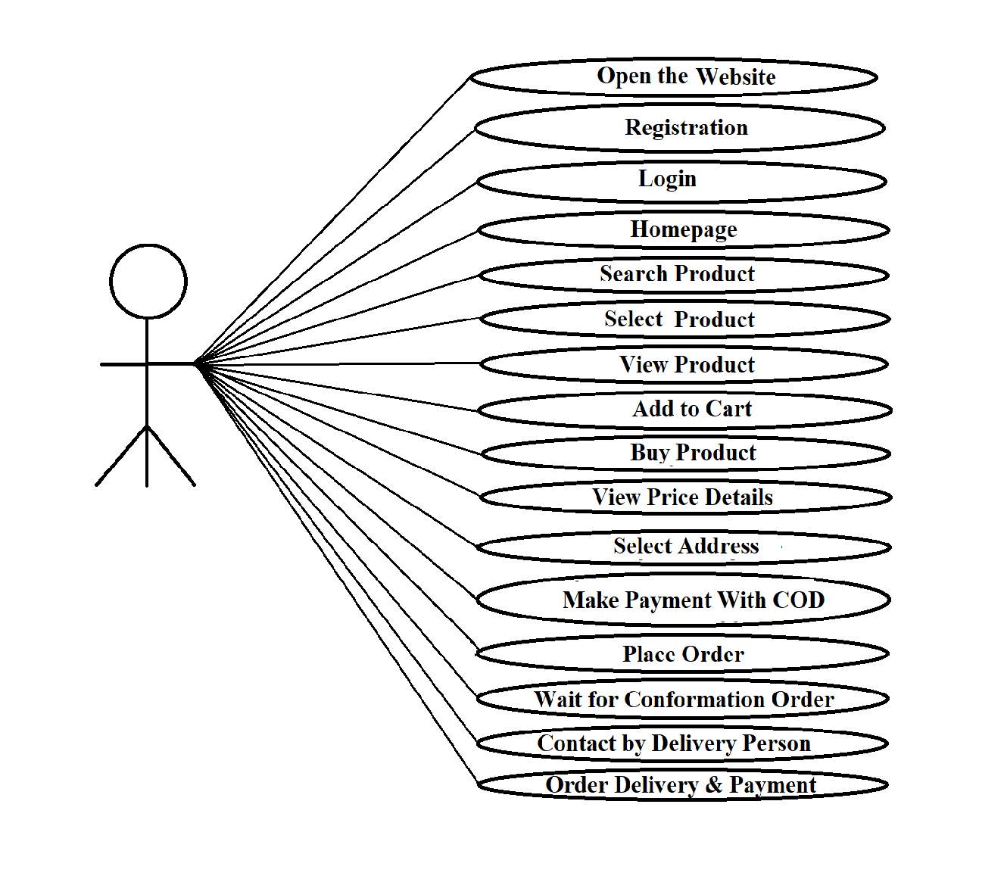

1. **Draw usecase on online shopping product using**

**payment gateway.**

